Distinct country name
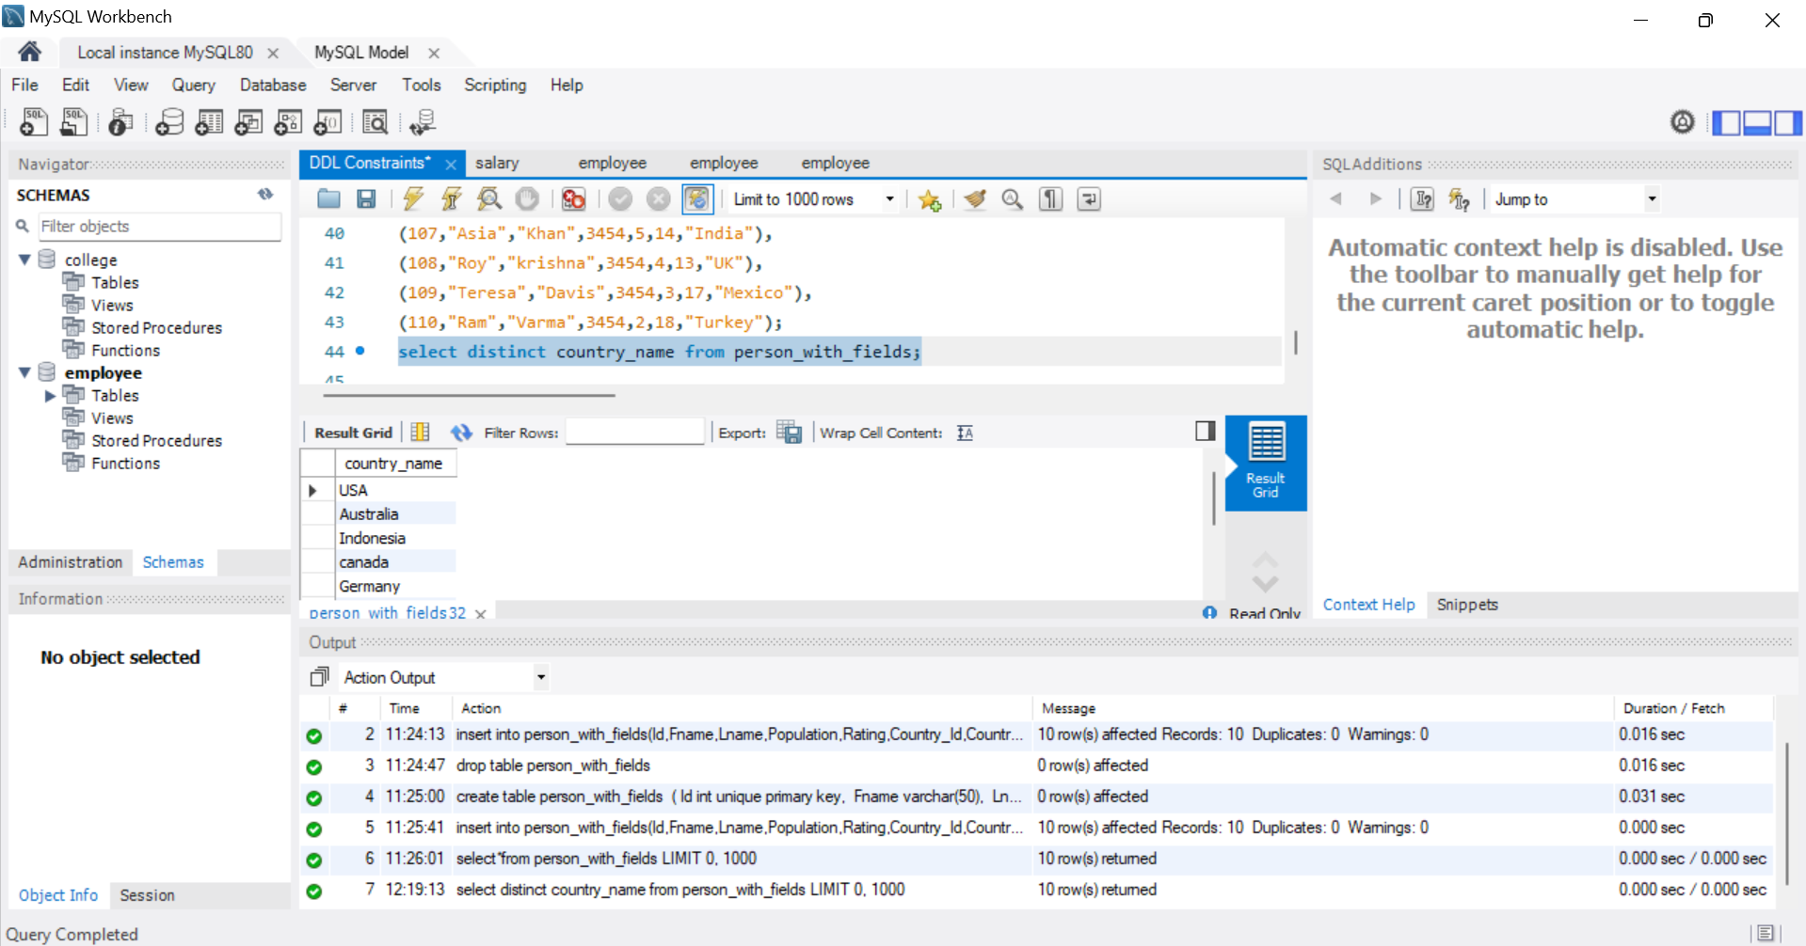
Find all persons with a rating greater than 4.0.
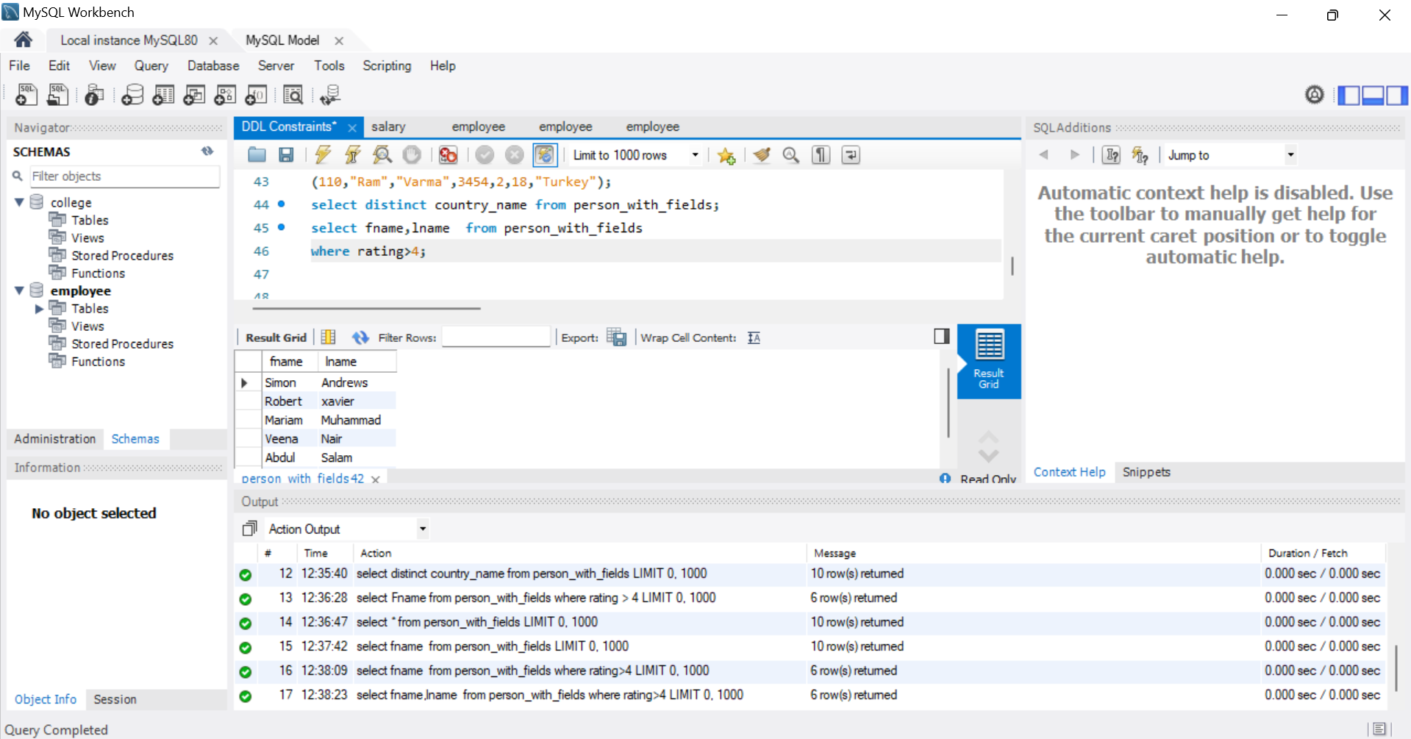
Find countries with a population greater than 10 lakhs.
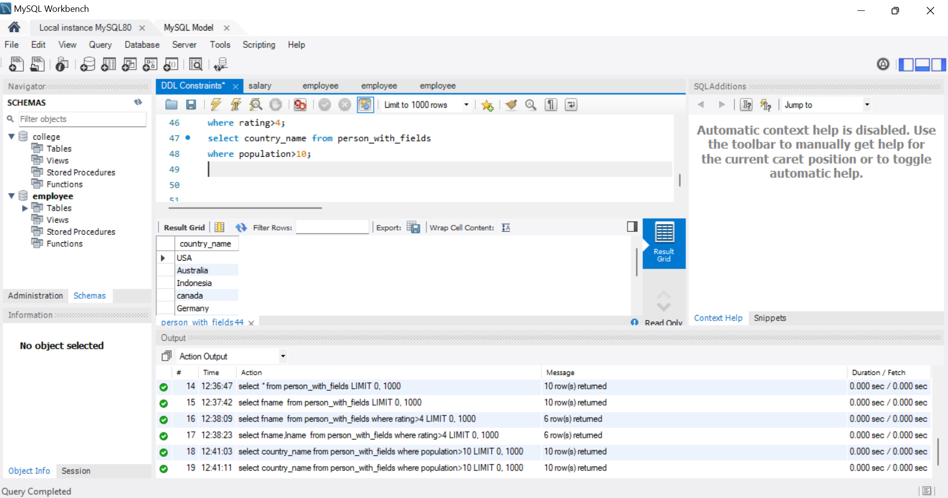
Find persons who are from 'USA' or have a rating greater than 4.5.
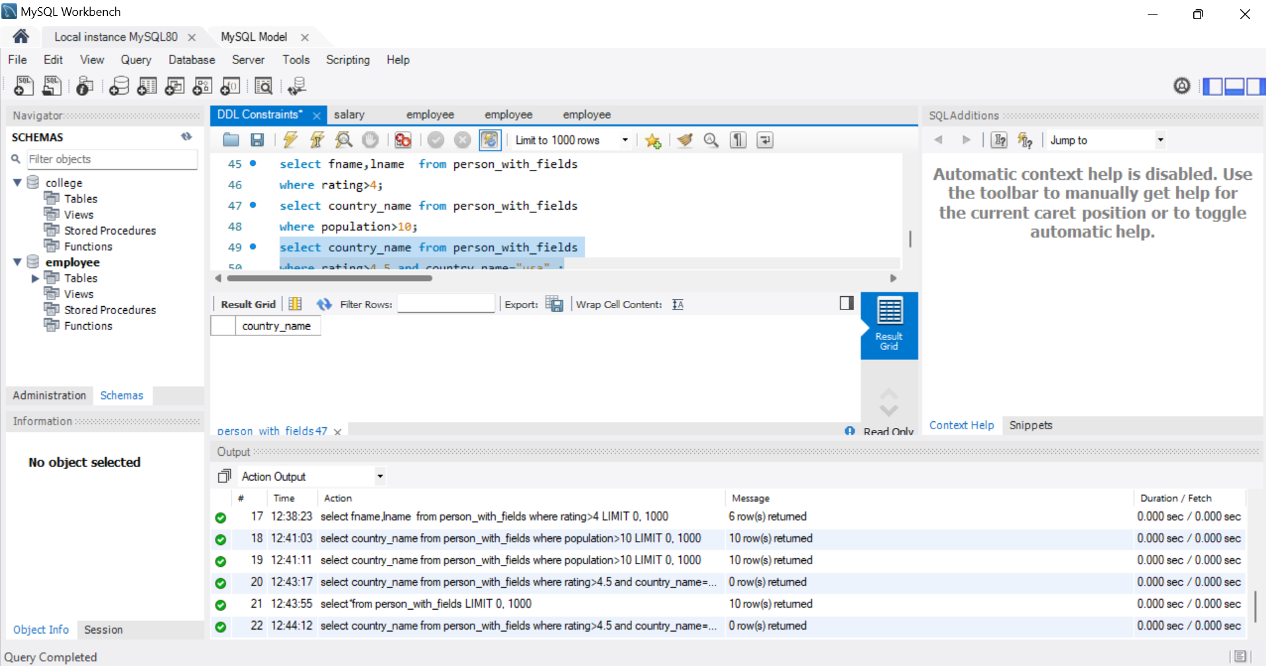
Find all persons where the country name is NULL.
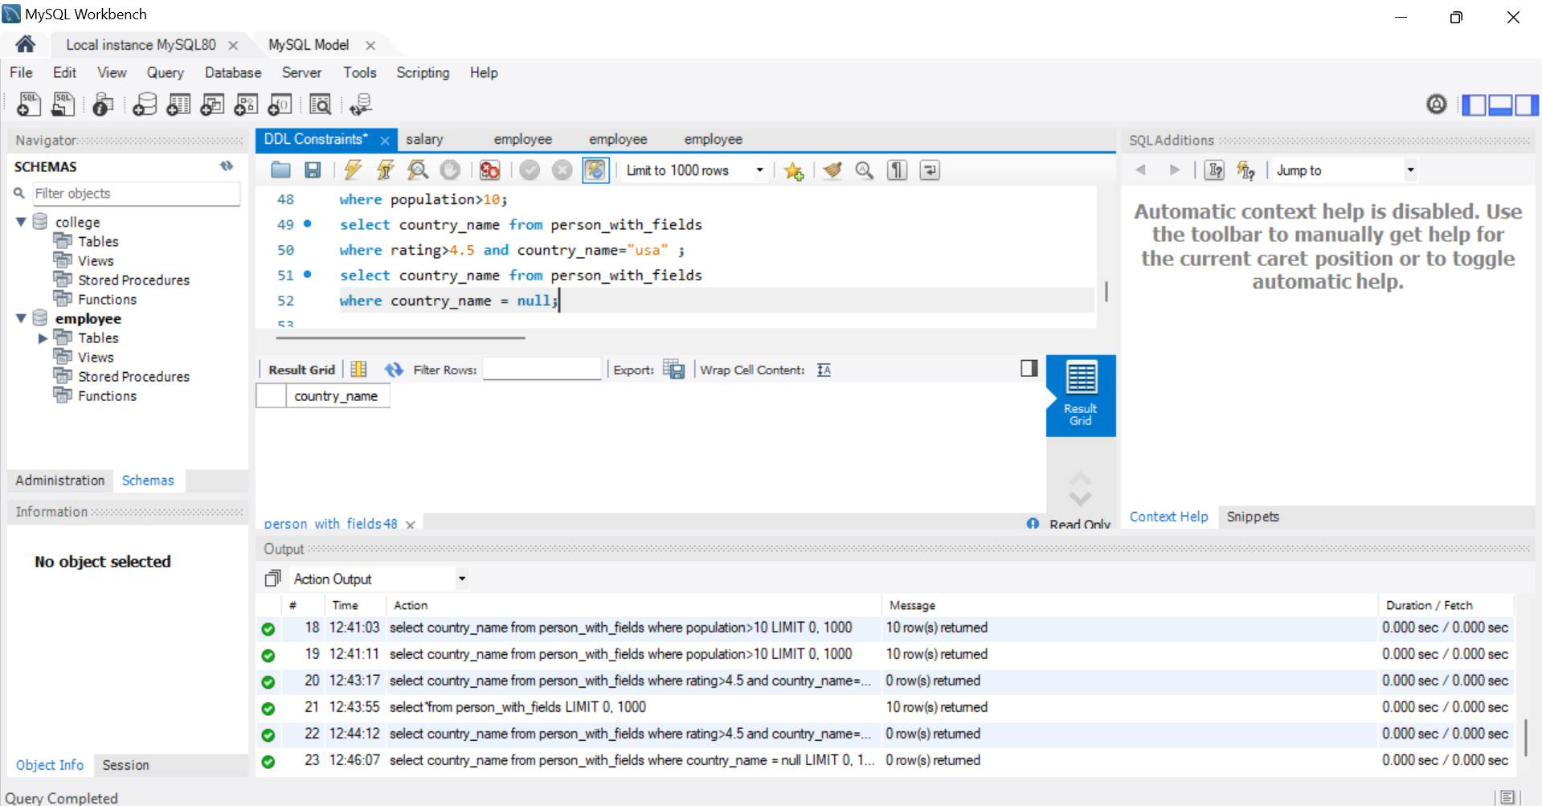
Find all persons from the countries 'USA', 'Canada', and 'UK'.
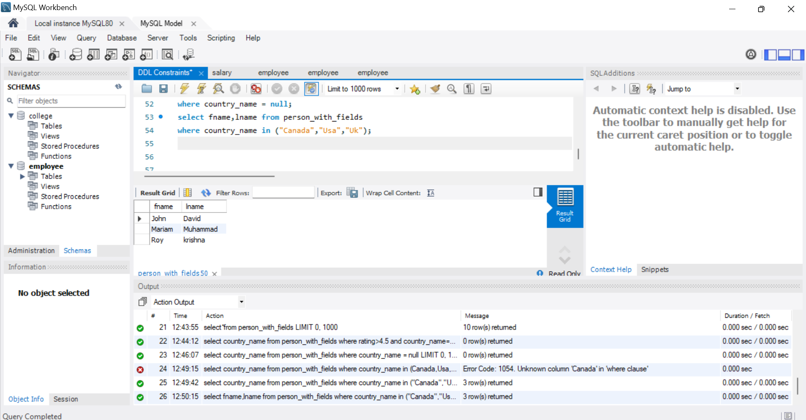
Find all persons not from the countries 'India' and 'Australia'
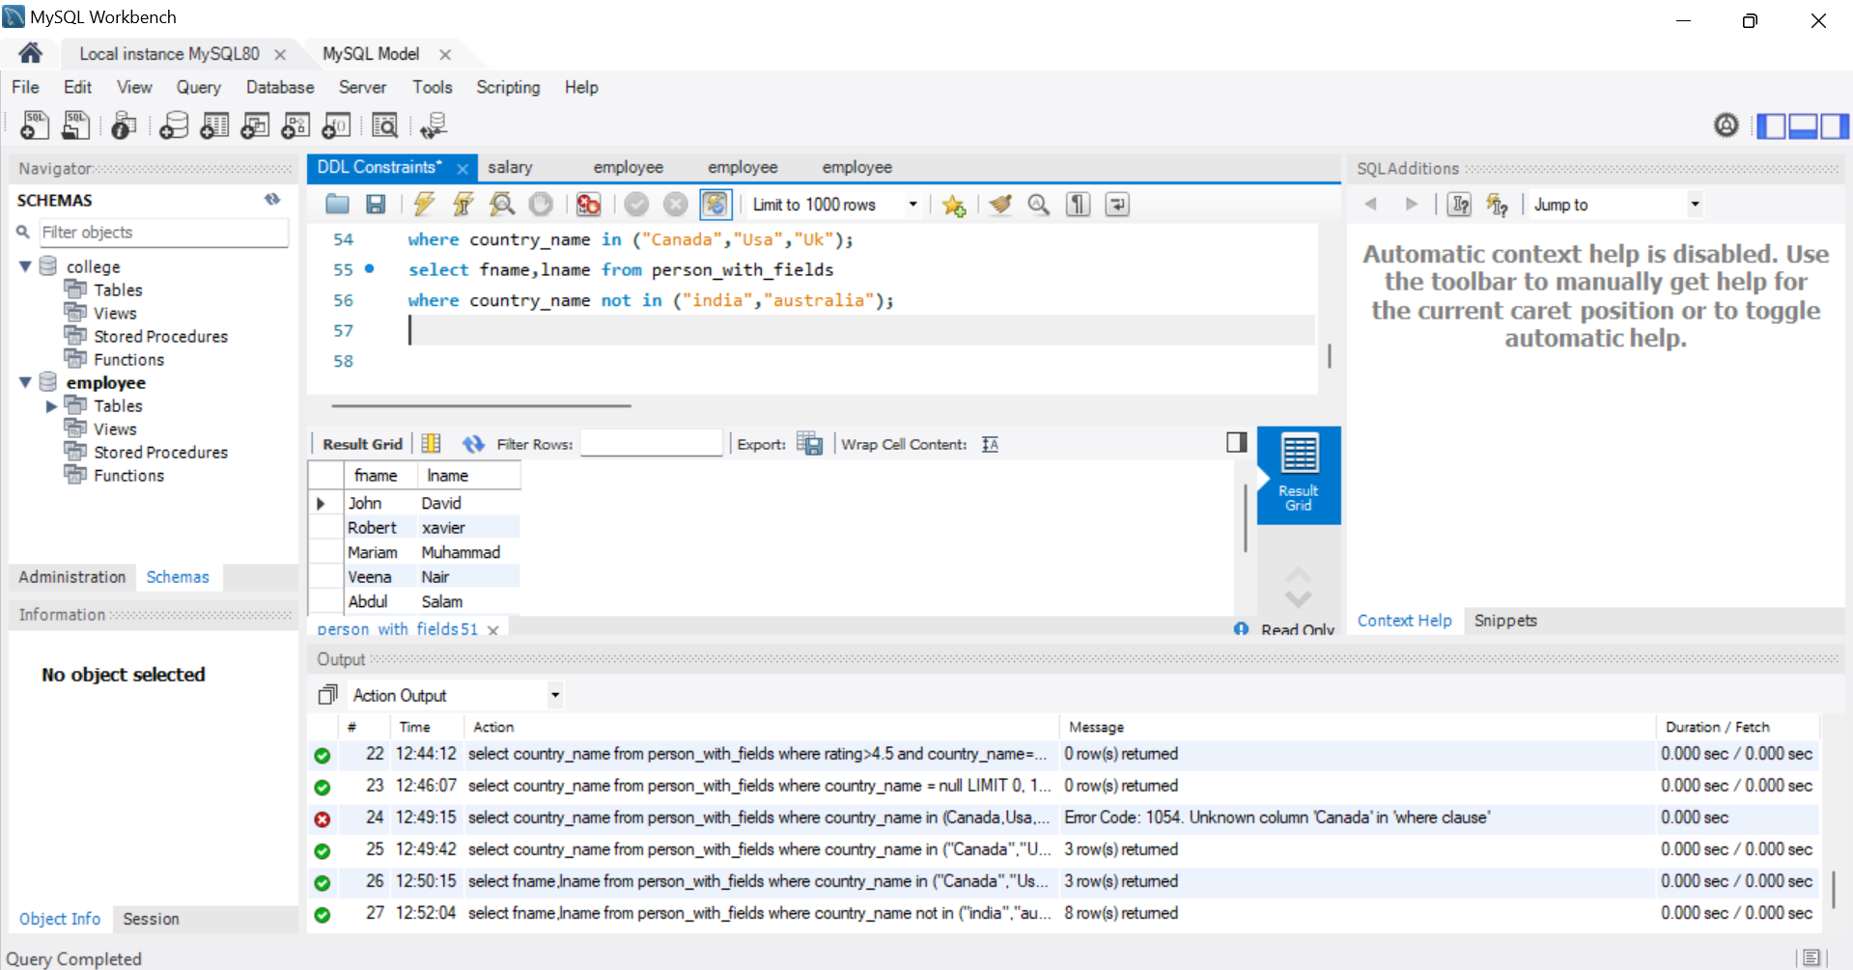
Find all countries with a population between 5 lakhs and 20 lakhs.
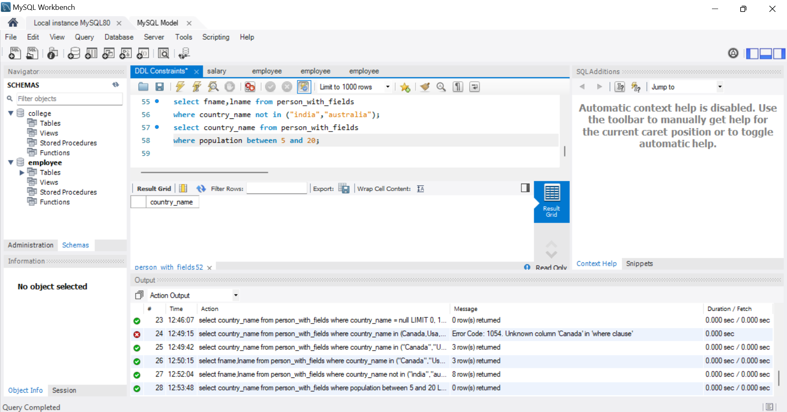
Find all countries whose names do not start with 'C'.

